## 

DEFENCE ANALYTICS

Reporting

Design & Standards

Guide

*Version 1*

15/05/2019

# Tables of Contents

1. Tables of Contents 2

2. Introduction 3

3. Good Report Design Principles 4

3.1. SUCCESS Formula from IBCS Standards 4

3.2. Fundamental Steps 5

3.3. Effective Report Organization 6

3.4. Report Design Principles 8

3.4.1. Page Layout & Template 8

3.4.2. Data Context 8

3.4.3. The Concept of Data Ink 8

3.5. Effective Use of Colours 9

3.6 Effective Use of Tables 11

3.7 Effective Use of Graphs 13

3.8 Effective Formatting Example 17

3.9 Common Mistakes and Preferable Visualizations 18

4.0 Web Intelligence Development Best Practices 22

4.1. Metadata management 22

4.1.1. Web Intelligence Document 22

4.1.2. Tabs 23

4.1.3. Queries 23

4.1.4. Variables 23

4.1.5. Blocks 23

4.1.6. Bilingualism 24

4.2. Techniques for Data Sources 25

4.2.1. Purging Data 25

4.2.2. Type of Data Sources 25

4.2.3. BEx Queries Specifics 25

4.2.4. Performance Tuning 25

4.3. Techniques for Report Elements 27

4.3.1. Formulas 27

4.3.2. Platform Integration 28

4.4. Ensuring Best Practices Have Been Implemented 29

4.4.1. Best Practices Checklist 29

Appendix – References 30

# Introduction

This document is intended to provide tips and guidance for the design of effective Business Objects Web Intelligence reports within DND as well as technical best practices and naming conventions. It focuses on the effective design of tables and graphs as they are the common structures composing reports and dashboards. It also provides technical best practices for authors.

Using this guide and respecting its guidelines will help users create well designed, easy to maintain, efficient and performant reports that convey information in a clear and compelling manner, in order to foster adoption.

SAP BusinessObjects Web Intelligence (WebI) is a self-service tool and a component of the SAP BusinessObjects Business Intelligence Platform. It is used to access and share data with others and allows authors to create interactive analysis, standards reports & advanced visualizations or to merge data from different data sources into a single report.

# Good Report Design Principles

## SUCCESS Formula from IBCS Standards

**S AY**  Convey a message  
 *Messages in reports and presentations can detect, evaluate, explain, warn, complain, threaten, excuse, suggest, or recommend something interesting. Make sure to deliver these messages in a complete sentence in order to be understood. Message should be formulated as precisely as possible.   
Explaining the reasons for a detection (explanation) or even deriving a suggestion on how to solve the problem or at least on how to further proceed can add value.*

**U NIFY**  Apply semantic notation  
  
*In order to facilitate reading, unify and standardize terminology, descriptions, dimensions measures scaling and abbreviations.*

**C ONDENSE**  Increase information density  
 *Intent to present most of the information in one page by using small components, maximizing use of space, reducing non data ink, add more data elements to charts, add supplementary data with table objects when necessary.*

**C HECK**  Ensure visual integrity

*Apply good practices to visualizations: avoid manipulated axis, avoid misleading representations, and use same scales, show data adjustments impact (e.g. when currencies or inflation has an impact on long term series).*

**E XPRESS**  Choose proper visualization

*By choosing the appropriate type of chart, the report will convey the right message with the underlying facts as soon as possible.*

**S IMPLIFY**  Avoid clutter

*Avoid unnecessary components and decorative styles. Prefer a clean layout without distractive details and without redundancies.*

**S TRUCTURE**  Organize content

Follow a logical structure forming a convincing storyline, for example by using a hierarchical structure of elements, use collectively exhaustive elements and do not overlap elements belong to the same group. Use consistent terms, items, wording across elements.

## Fundamental Steps

The first step of report development is to understand the message of the report and the needs of the recipients.

Then, after determining the full purpose of the report, the layout and formatting can be consciously designed to communicate that message effectively. Begin report design by determining the best structure for your data and the message you wish to emphasize.

Once the report structure has been determined, individual graphs and tables should be designed and formatted to present the data as clearly and efficiently as possible.

## Effective Report Organization

**Strive for a clean design.** A clean design is one that supports visual thinking - i.e. helps users access the information more effectively with less conscious effort. This is particularly useful in very data heavy reports. Reports can help support visual thinking when the individual tables and charts are structured in a simple and logical way. It is even better when the collection of tables and charts are arranged in a way such that their spatial relationship helps a user digest the information quickly.

Organize and position elements depending on their relative importance. The following diagram represents the importance of the elements depending on eye movement and which parts of the screen will be seen first. Priority of elements is therefore derived from the focus they naturally get.

**Priority 1**

**Priority 2**

**Priority 3**

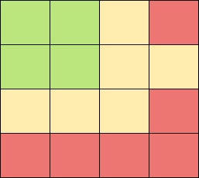 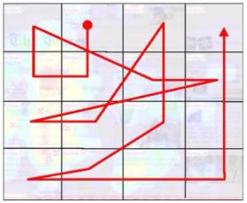

While organizing the components of a report keep the following principles of visual perception in mind. They can be used to indicate how different blocks of data are related to each other:

* Objects that are close together are perceived as a group;
* Objects that share similar shape and colour are perceived as a group;
* Objects that have a boundary such as a box or background shading are perceived as a group;
* Objects that are aligned together are perceived to be a continuation of one another; and
* Objects that are connected (e.g. by line or arrow) are perceived to be a continuation of one another.

**Element organization principles:**

* Information needs to be presented in a well organized manner. Data should be arranged such that it can be consumed easily based on importance and proper viewing sequence. Data that needs to be compared should be arranged and designed to make comparisons easily possible.
* Avoid introducing meaningless variety. E.g. You have placed four bar charts on a report so you feel compelled to make the fith graph a pie chart just to introduce some variety to the report.
* Avoid exceeding the boundaries of a printed page or monitor display, or squeezing too much information on a page. Displaying too many details or too much precision can overwhelm the user.
* When designing reports it is important not to overload the user with unnecessary information that distracts the user and makes it difficult to interpret the data.
* Charts and corresponding tables must be aligned and made the same size. This offers a visual cue that they are related.

## Report Design Principles

### Page Layout & Template

The standard template, includes a header that has the data refresh date as well as a page footer that includes the page number. The data refresh date is the report calculation date or load date, depending on the type of data source and available dates. The page header should also contain a meaningful report title.

Do not rely on the default formatting options of the software and rather apply design principles that enhance your unique report.

### Data Context

Provide meaningful context in order to understand where the data is coming from and how to interpret it. Include descriptions of any conditions that may not be obvious to the viewer (e.g. how data is filtered or how a calculation is defined).

Display dimensions labels, descriptive titles & subtitles when necessary, scales and any other information that is required to understand the meaning of the data.

Display data accurately:

* + Values rounded inappropriately diminish their value.
  + Inappropriately dropping values or groups result in an incomplete data set.

### The Concept of Data Ink

Data ink is the ink (or pixels) in tables and graphs that actually display the information you want to communicate. “*Data-ink ratio*” is defined as the ratio of data ink to total ink used to display the graphic.

It is recommended to maximize the data-ink ratio by eliminating or reducing as much non-data ink as possible, within reason.

Non-data components should be visible enough to serve their supporting purpose, but not so visible as to detract attention from the data. This is achieved by eliminating or de-emphasizing (e.g. use thinner lines, lighter colours) components such as backgrounds, borders, grid lines, tick marks, and axes.

## Effective Use of Colours

|  |  |  |
| --- | --- | --- |
| Colour choices should be made thoughtfully. Generally, use non distractive colours. Avoid dark saturated colours in favour of lighter hues as they are more pleasing to the eye. Some colours demand our attention, others are more subtle. Pay attention to colour blindness which is a common affliction that makes some colours impossible to be distinguished. Projectors contrast also tends to make some colours impossible to be distinguished and therefore need to be tested when colour schemes are being determined. Example of a pale, non-distractive colour set: | | |
|  |  | |
| Do not over use colours and conditional formatting. Use them to highlight exceptions. Avoid the use of too many colours in a graph. Different bar colours should only be used to distinguish different measures (e.g. yearly sales versus projected sales) otherwise only one colour should be used (e.g. yearly sales for 10 different regions). Below is a good example of data highlight with a specific colour:   |  |  |  | | --- | --- | --- | | ***Past 12 Months*** | ***Metric*** | **Actual** | |  | **Revenue** | **54M** | |  | **Gross Profit** | **24%** | | | |
| Data highlighting can be done with different techniques, including using a different colour. Important information and only important information should be made visually prominent and highlighted to stand out. | | |
| |  |  |  |  | | --- | --- | --- | --- | |  |  |  |  | | **Color Hue** | **Position and alignment** | **Color saturation** | **Size** | |  |  |  |  | | **Color brightness** | **Orientation** | **Texture** | **Shape** | | |  |
| Use colours in a meaningful and consistent way. Colours that contrast draw our attention while similar colours appear to make things look related. Above examples show best practices for colour-coded quantitative ranges: | | |
| |  |  | | --- | --- | | **Sequential Color Scale**      **Diverging Color Scale** |  | |  | |

## 3.6 Effective Use of Tables

The decision whether to use a table or a graph to display information can usually be decided by asking one question:

***“Am I conveying many individual data points,***

***or am I trying to show an overall trend instead?”***

If it is important that the report reader see individual data points then a table should be used. Otherwise a graph may be a better choice.

**Tables are effective when:**

* Users need to look up individual values;
* Users need to compare particular values;
* Data values must be precisely known;
* Users need to show both details and summaries; or
* Multiple units of measure are included.

(e.g. quantity of units sold and value of units sold)

|  |  |  |  |  |  |  |  |  |  |  |  |  |  |
| --- | --- | --- | --- | --- | --- | --- | --- | --- | --- | --- | --- | --- | --- |
| **Year** | Jan | Feb | Mar | Apr | May | Jun | Jul | Aug | Sep | Oct | Nov | Dec | **Monthly Average** |
| **2000** | 138.1 | 138.6 | 139.3 | 139.5 | 139.7 | 140.2 | 140.5 | 140.9 | 141.3 | 141.8 | 142.0 | 141.9 | **140.3** |
| **2001** | 142.6 | 143.1 | 143.6 | 144.0 | 144.2 | 144.4 | 144.4 | 144.8 | 145.1 | 145.7 | 145.8 | 145.8 | **144.5** |
| **2002** | 146.2 | 146.7 | 147.2 | 147.4 | 147.5 | 148.0 | 148.4 | 149.0 | 149.4 | 149.5 | 149.7 | 149.7 | **148.2** |
| **2003** | 150.3 | 150.9 | 151.4 | 151.9 | 152.2 | 152.5 | 152.5 | 152.9 | 153.2 | 153.7 | 153.6 | 151.5 | **152.4** |
| **2004** | 154.4 | 154.9 | 155.7 | 156.3 | 156.6 | 156.7 | 157.0 | 157.3 | 157.8 | 158.3 | 158.6 | 158.6 | **159.9** |
| **2005** | 159.1 | 159.6 | 160.0 | 160.2 | 160.1 | 160.3 | 160.5 | 160.8 | 161.2 | 161.6 | 161.5 | 161.3 | **160.5** |
| **2006** | 161.6 | 161.9 | 162.2 | 162.5 | 162.8 | 163.0 | 163.2 | 163.4 | 163.6 | 164.0 | 164.0 | 163.9 | **163.0** |
| **2007** | 164.3 | 164.5 | 165.0 | 166.2 | 166.2 | 166.2 | 166.7 | 167.1 | 167.9 | 168.2 | 168.3 | 168.3 | **166.6** |
| **2008** | 168.8 | 169.8 | 171.2 | 171.3 | 171.5 | 172.4 | 172.8 | 172.8 | 173.7 | 174.0 | 174.1 | 174.0 | **172.2** |
| **2009** | 175.1 | 175.8 | 176.2 | 176.9 | 177.7 | 178.0 | 177.5 | 177.5 | 178.3 | 177.7 | 177.4 | 176.7 | **177.1** |
| **2010** | 177.1 | 177.8 | 178.8 | 179.8 | 179.8 | 179.9 | 180.1 | 180.7 | 181.0 | 181.3 | 181.3 | 180.9 | **179.9** |

**Example of a table being more effective than a chart:**

The graph below has a lot of visual impact. It jumps off the page and demands attention. But the following plain table presents the same information more clearly and simply. The table communicates a fuller story and is much easier to read. It provides meaningful context for the sales information (US $, As of March 15). It also adds points of comparison for the sales figures (percentage of sales per region, performance against planned sales, projected sales).

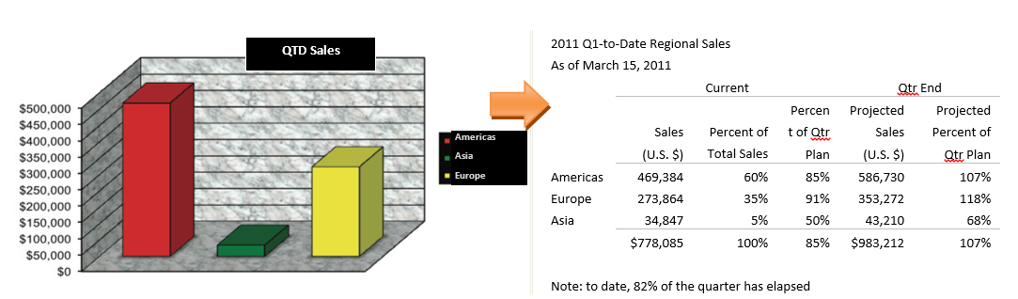

**Designing a table:**

* White space is the preferred means for arranging data in rows and columns. Gridlines tend to fragment the data and introduce clutter. To delineate rows and columns:
* Use white space alone whenever space permits;
* Use a subtle rule or underline (horizontal line) to distinguish headings and summaries;
* Avoid grids altogether (horizontal lines and vertical lines). Use them only if there is not enough space available to delimit values with whitespace alone; and
* Make rows/columns containing group summaries visually distinct from details by horizontal rule lines or bolding.
* Be consistent with font type and size with all headings and label the same font size, type, and colour.
* Highlight important textual information and make it stand out from the rest of the page by increasing size or boldness of font, by using italics or a different font.
* Ensure data is ranked and sorted in order to convey more information.
* Dates can be either left or right aligned. Maintain an equal number of characters for each data part (month, year, and day) by padding with zeroes.
* Right align numerical data and headers. Align the decimal by padding zeroes to the end of numbers that have less precision.
* Left align text fields and headers unless all strings are exact same length (e.g. Mon, Tue, Wed). Capitalize the first letter.
* Avoid useless embellishments (borders, useless colours, shadows …).
* Specify units of measures ($, kg, km …) in headers or in data cells. Use abbreviations for thousands and millions (e.g.: k$ or M$).
* While summaries are usually placed in group footers consider placing summaries in group headers if the data exceeds one page in length.
* If data is organized into groups or breaks then repeat or freeze columns and rows headings at the beginning of each group or page.

## 3.7 Effective Use of Graphs

Due to their visual nature, graphs can reveal more than a collection of individual values as found in a table. Graphs allow users to visualize the big picture or overview of a data set. An overview summarizes the data’s essential characteristics and allows us to detect what is routine versus what is exceptional.

It is difficult to quickly compare values using a table of numbers. When numbers are displayed in tables they must be read one at a time, and at most only two numbers can be compared at a time. However, graphs make it possible to visualize all the values at once and to quickly see how they differ, as long as the number of data series is limited (to avoid confusion)

**Graphs are effective when:**

* You want to show the big picture rather than examine individual values;
* The message is contained in the shape of the values (i.e. patterns, trends, and exceptions); or
* You want to show relationships among entire sets of values.

**Designing a graph:**

* Avoid cluttering the display:
  + Avoid gridlines or use subtle ones (light grey lines works well). They can be useful in some cases and can help to ease the lookup of values, the comparison of values, the perception and comparison of localized patterns;
  + Tick marks should be subtle and are only needed on numerical axis. Minor tick marks should be avoided since most graphs are not intended to give such a high level of precision.
  + Avoid placing data values on the plot area of the graph. If precise data values are needed then it is often best to display values as part of the graph labels or in a separate table below or beside the graph;
  + Avoid borders around bars unless you are trying to highlight the bar;
  + When multiple axis are used, axis labels colours and graph bars colours should be similar to provide a visual cue that the axis correspond to the bars or lines; and
  + Avoid useless embellishments (3D, borders, gridlines, shadows, special effects, titles if they are not necessary …).
* To highlight values in charts, use a more vibrant colour, increase the width of bars and lines, place a border or shading around particular values or use a contrasting colour; and
* Ensure data is ranked and sorted in order to convey more information. Graphs are usually more effective if the values are ranked in ascending or descending order, or sorted by the group label.
* Axis should begin with a zero line to give accurate comparisons. If an axis does not start at zero a description or label should be added to call attention to the fact. Graph axes not starting at zero tend to skew the comparisons.

**Common representations and their use cases:**

|  |  |  |  |  |
| --- | --- | --- | --- | --- |
| Bar chart | Non temporal distribution of comparable values.  Main dimension must have limited distinct values or a top X (ranking) is recommended. | | C:\Users\hermosa.a\Desktop\htshtsgfhgfsh.JPG | |
| Stacked bar chart | Non temporal distribution.  Values comparison for several dimensions.  Colour dimension must have very limited distinct values and should be used to highlight a specific event in data series. | | |  | | --- | | **Declines in Bank Market Values Since the Financial Crisis Began** | | █ Loss from Qtr 2, 2007 to Jan 20, 2009 | |  | | |
| Line chart | Temporal distribution.  Never use if time is not involved or if there are not enough data points to produce trend lines that make sense. When using a secondary dimension (multiple lines), a maximum of 4 distinct values is recommended. Distance and relationship between the trend lines has to be readily apparent. | |  | |
| Choropleth Maps | For geographical data only.  Analysis or undertaken actions have meaning on a spatial standpoint. | |  | |
| Bubble Charts | Representation of a combination of 3 metrics (X and Y coordinates, size). Bubble colours can represent individual status or can be used to group sets of data. | |  | |
| Tree Maps | Comparison of 2 metrics (area and colour). Colour coding is usually more appropriate for percentages. | |  | |
| Bullet Charts | Represent metrics values against target and comparable values (benchmarks or previous values). Best suited for KPIs (Key Performance Indicators). | | C:\Users\hermosa.a\Desktop\Captureujhykhfkhfk.JPG | |
| Heat Maps | Seasonal metric tracking. Horizontal axis is a time-series. Colour coding is usually more appropriate for percentages. | |  | |
| Pie Charts | Compare a **maximum** of 2 values or a **maximum** of 2 groups of values against each other. |  |  |
| Variance | Show absolute variance or contribution to variance with bar charts, pin charts or waterfall charts |  |  |
| Box plot | Used to show statistical information on a population or data series. Usefull tyo identify outliers or normal distribution of elements. |  |  |

## Effective Formatting Example

Subtle **grid lines**

**No data values** on the plot area  
Plot area **background clear and light**

|  |  |  |
| --- | --- | --- |
|  | Both Coasts  **No borders around** bars (no highlight needed) |  |
| OpDef Count & Unique Parent Equip Count |  | **Unavailable Days** |
|  | ■ **OpDef count**  ■ **Unique Parent Equip count** ■ **Unavailable Days**  **Legend as small as possible** with no border or title |  |

|  |  |  |  |
| --- | --- | --- | --- |
| Year | OpDef Count | Unique Parent Equip count for Year | Sum unavailable days (ERN/year) |
| 2010 | 759 | 270 | 37,204 |
| 2011 | 704 | 204 | 31,513 |
| 2012 | 657 | 192 | 28,704 |
| 2013 | 236 | 104 | 10,988 |
| 2014 | 668 | 216 | 37,159 |
| 2015 | 550 | 178 | 22,043 |
| All Years | 3,574 | 509 | 167,611 |

Axis beginning with a **zero line** to give accurate comparisons

**Subtle tick marks** and no minor tick marks

Right **axis labels corresponding in colour** to the graph bars

Data **sorted   
(**by group) label)

**No useless embellishments embellishments**

**Date field right aligned** with equal number of characters

**Unit specified** in headers

**Right aligned numerical** data and headers

## 3.9 Common Mistakes and Preferable Visualizations

|  |  |
| --- | --- |
| **Never use Pie Charts with more than 2 comparable values.** They communicate data poorly because it is difficult to visually compare sizes when they have similar values. It is also difficult to match pie slices to the correct category by using the legend. Use bar charts instead. | |
|  | A  B  C  D  E  F  G |
| **Avoid useless embellishments such as 3d effects and shadows.** These tend to clutter the graphs and make them more difficult to interpret. | |
|  |  |
| **Do not use Bar Charts for time dependant series.** Use line charts or spark lines instead. | |
|  |  |

|  |  |  |
| --- | --- | --- |
| Do not use different colours when it is not necessary.  They distract attention and do not highlight any specific behaviour. | | |
|  | |  |
| Don’t represent missing values with zeroes.  This inaccurately represents data. Use blanks instead. | | |
|  | |  |
| A Speedometer consumes a lot of space to display only 1 metric.  Consider Bullet charts than can display comparable values and optimize the space used on screen. | | |
|  | |  |
| Do not hide the zero line when using column charts.  Otherwise, the comparison between values is not possible. Comparable data must have identical scales. | | |
|  | |  |
| Do not use a stacked bar chart with too many metrics (colours). Data cannot be easily compared for each specific section. Use a stacked area chart instead. | | |
|  | |  |
| Use horizontal bar graphs instead of vertical ones when the labels are long as they are easier to read.  With horizontal bars you can also have a long horizontal label while vertical bars require long labels to be rotated 90 degrees to fit on the graph. Vertical bars are also usually perceived as time series. | | |
|  |  | |
| Do not overload the user with unnecessary information It distracts the user and makes it difficult to interpret the data. Highlight data points by removing, deemphasizing and regularizing as much non-data ink as possible. | | |
| C:\Users\hermosa.a\Desktop\SFDGHGFHGFSJH.JPG | | C:\Users\hermosa.a\Desktop\SDFZFXBZXBFBD.JPG |
| [data-ink-heavy](http://www.fourstepsresearch.com/wp-content/uploads/2014/04/data-ink-heavy.png) | | **[data-ink-lite](http://www.datavizcatalogue.com/)** |

# 4.0 Web Intelligence Development Best Practices

## 4.1. Metadata management

### 4.1.1. Web Intelligence Document

When creating a Web Intelligence document, it is recommended that it is created in the ‘My Documents’ section using the standard template, found in “Templates and resources” folder.

The document should be given a meaningful business name (no technical reference). It should be clear and concise as to what the document’s main purpose is, in only a few words.

A detailed description of the report is mandatory. This description can be preceded or suffixed by the report’s version number.

Keywords (not mandatory but recommended) are separated by a space character to ease search. Title, Description and Keywords are found on the **General Properties** of the Web Intelligence Document.

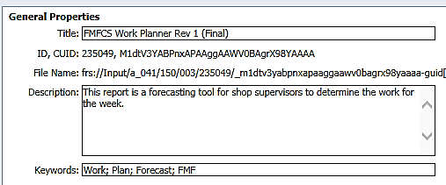

### 4.1.2. Tabs

All report (tabs) should have a simple and short meaningful descriptive title

Do not specify more than 31 characters as some Excel versions truncate tab names

### 4.1.3. Queries

Queries are named according to their role. Use concise titles and capitalize first letters:

* Use the subject area and/or the data granularity level.  
  *e.g.: Query 1: Region Sales*
* *Query 2: Territory Sales*
* Use the prefix “DIM” when creating a query that will list dimension values.  
  *e.g.: DIM-Time*

### 4.1.4. Variables

Name variables with appropriate business terms:

* Names are visible to end-users;
* Prefix with TXT when the variable contains a fixed label value; and
* Prefix with CONST when the variable contains a fixed value (e*.g. a parameter*).

### 4.1.5. Blocks

Name blocks (charts, tables, cells) to ease design navigation and to make it easier to align the blocks relatively to each other:

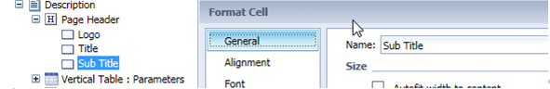

### 4.1.6. Bilingualism

In order to create efficient and sustainable bilingual reports:

* Ensure the data and the metadata (fields names) are translated in the source system;
* Use the ***GetLocalized*** function to add terms for translation for all text strings (including within variables definition);  
  
* Use the BusinessObjects Translation Manager Tool to translate report and object names;
* Use **both languages in Input Controls** titles  
    
  They cannot be translated automatically and variables cannot be used in this context ; and
* Alternatively, when the translation tool is not accessible:
  + Use a formula in Web Intelligence that will capture the viewing locale of the user; or  
    e.g. : ***If( GetContentLocale() = ”fr-CA” ; “Titre” ; “Title”)***
  + Display headers and titles in both languages.  
    e.g.: ***Title | Titre***

## 4.2. Techniques for Data Sources

### 4.2.1. Purging Data

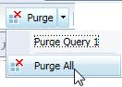**Important:** Queries and prompts data MUST be **purged** before document is saved:

* This ensures data is not visible by users not entitled to see it; and
* This reduces drastically the size of the document in the repository.

### 4.2.2. Type of Data Sources

Use managed data sources (Universe, BEx Query, Web Service and Analysis Views) whenever possible. The use of the following sources is not recommended:

* Excel spreadsheet as the data quality is not controlled;
* Custom SQL (editing a universe generated SQL) as it breaks semantic layer rules; and
* Free hand SQL as it is not sustainable in the long term.

### 4.2.3. BEx Queries Specifics

The following elements have to be considered when a BEx query is used as a data source:

* Limit the number of levels or select specific members to optimize performance of the hierarchies;
* Prefer inclusive filters (in) rather than exclusive filters (not in);
* Remember that mandatory filters in BEx queries force the generation of the list of values;
* Ensure the selected hierarchy version exists in other environments when developing in a non-production environment or the report will not refresh properly. This also applies to Hierarchy selection variables; their default values have to be set to a version that exists in other environments, particularly when the BEx hierarchy selection (prompt) is hidden and cannot be changed; and
* Use the most current version of the hierarchy. The Hierarchy version that is selected has to be sustainable. The common practice is to have a version in BW that will always be current and that can be used in the reports without having to update the report when there is a new version created.

### 4.2.4. Performance Tuning

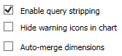

Do not keep objects in queries’ results that are not used in the report. Use query stripping options (document properties) for OLAP sources and cleanup unused elements.

Limit the number of rows at the query level with query filters whenever possible instead of applying a filter at the report level

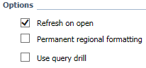

Select the “Refresh on Open” document property in order to automatically and immediately start refreshing the report when the users open it.

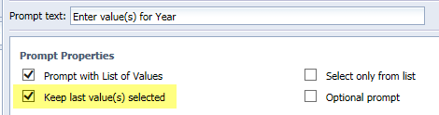

Check the “keep last value(s) selected” option for prompts. It will make successive reports refresh faster for the end-user.

## 4.3. Techniques for Report Elements

### 4.3.1. Formulas

All variables that are coded should be used in the report. If not, clean up unnecessary variables. This simplifies impacts analysis and maintenance.

**Use variables whenever possible** and limit the usage of formulas in cells / blocks. This allows future changes to be done at the variable level and then propagated everywhere the variable is used. If you use a formula, each cell where the formula is would have to be manually updated. This is particularly recommended when using **Input Controls** as all their settings would have to be set up again if the data field changes.

When performing a division, use a formula to take care of a potential “0” divisor (denominator) to avoid a "#DIV/0” error message. Generally take in account potential error messages when designing formulas.

*i.e.: if ( [Region Total] = 0 ; 0 ; [Amount] / [Region Total]*

If you can use reference to other variables in a variable, limit the depth to a maximum of 2 levels in order to facilitate maintenance. Example:

*Variable A: [Query Object 1] - [Query Object 2]*

*Variable B (Level 1): [A] / 1000*

*Variable C (Level 2): [B] + [D]*

Embed images with “http://boimg” or standard http URLs to minimize the size of the reports.

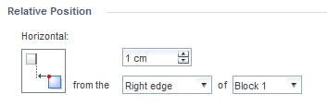

Components must be aligned relatively to other components.

### 4.3.2. Platform Integration

When modifying an existing report that has already been promoted, keep in mind that the unique identifier of the report has to be preserved in order to allow the promotion process to succeed. The “save” action will preserve it where as the “save as” action will create a new unique identifier.

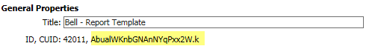

Use a relative path when using a link to another document of the platform (i.e. OpenDocument).   
Do not specify the web server name (complete URL path).



## 4.4. Ensuring Best Practices Have Been Implemented

### 4.4.1. Best Practices Checklist

Once the report has been designed, a checklist is used to ensure all document elements have been identified and implemented. The following checklist is available for use and can be easily printed or saved at the author’s discretion.

The checklist can be found [here](https://collaboration-admdia.forces.mil.ca/sites/ASC/Tech/CertPub/Forms/Activity.aspx).

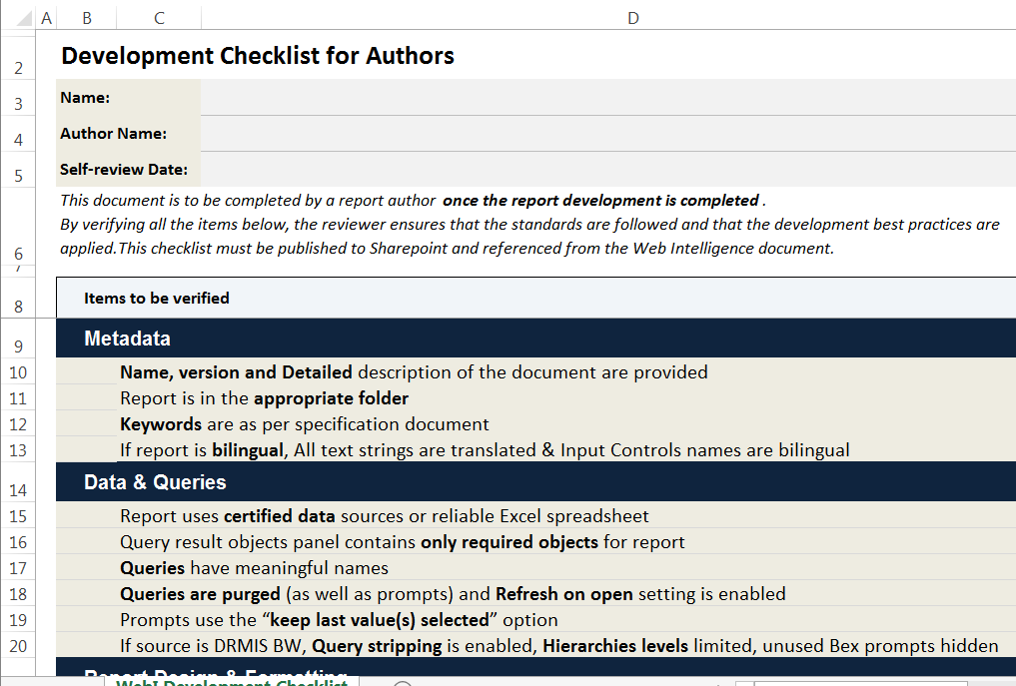

# Appendix – References

[Perceptual Edge](https://www.perceptualedge.com/)

Organization founded by Stephen Few, focusing on the tools and techniques of visual business intelligence to help you make better use of your valuable information assets.

[Data Visualization Catalog](https://collaboration-navy-marine.forces.mil.ca/ent/casc/CASC%20Shared%20Documents/CASC%20Solution%20Enablement/Web%20Intelligence%20-%20Design%20and%20Standards%20Guide.docx)

Reference library of different information visualisation types

[The Work of Edward Tufte](http://www.fourstepsresearch.com/wp-content/uploads/2014/04/data-ink-lite.png)

Edward Tufte is a statistician and artist, and Professor Emeritus of Political Science, Statistics, and Computer Science at Yale University. He wrote, designed, and self-published 4 classic books on data visualization.

[IBCS – International Business Communication Standards](https://www.hichert.com/)

HICHERT+FAISST website, HICHERT+FAISST serves as the IBCS® Institute, hosting the IBCS® project, giving IBCS® trainings, acting as the IBCS® certification body, and providing educational material on IBCS®.

*With thanks to the Royal Canadian Navy for developing & researching these standards.*